
444 Baskin Street South, Union Springs, AL 36089

REFRIGERATION CONTROLS AIR UNIT ADDITION 2021
AU-2A, 2B, 3A, 4A, 4B, 17A & 17B MANUAL

REFRIGERATION SYSTEM CONTROLLER

The refrigeration system control is based on Allen-Bradley’s Compact Logix’s 5380 platform. This controller is connected to all of the field equipment Input/Output (I/O) points for controlling and monitoring of equipment. The operator interface located on the panel door an Allen-Bradley Panelview 5310, 10” color touch screen. The PanelView is connected to the PLC via Ethernet and can be connected to the plant network for remote access.

MAIN “HOME” SCREEN AND SYSTEM BUTTONS

The Main Screen is the base screen for accessing and viewing the entire system. Critical systems information (i.e. area temperatures, humidity and status are displayed on this screen. Differing modes and status for equipment are represented by various colors. Below is an example of the “Main Screen” and with a Legend that shows the meaning of the colors for Air Units.

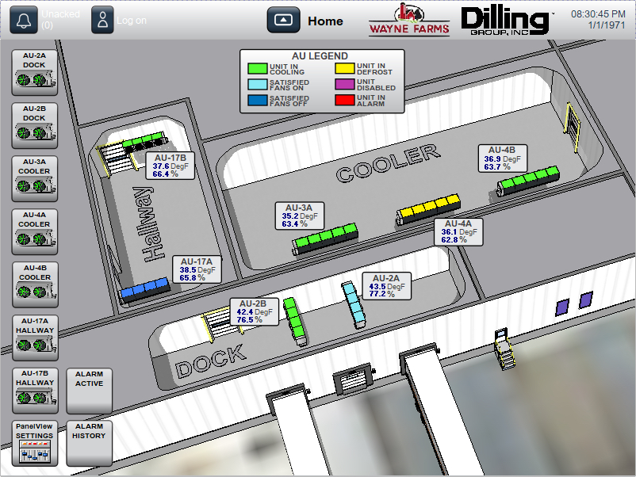
Main Screen

To view an Air Unit in greater detail select the desired button located down the left side of the screen. All full screens have the Banner located along the top, This banner allow an operator to return to the Main screen by selecting “Home”. Log into the system by selecting “Log On” default user name is WF, password is 1000. Users can be added during startup. Also acknowledge Alarms as well as see if there are any active alarms on the first button.

Evaporative Air Units Control

Detail Screen

From the main screen each air unit Detail Screens can be selected by pressing the desired air unit button on the left side of the screen. From this screen you can see detailed information about an air unit including, 1-hour trend, Valve status, Fan status, Runtime meters for fans and for unit cooling. Operating Mode information, Temperature Data including 24 hour & 14 day running average, Time until next defrost, High\Low Temperature, time and date of highest and lowest values recorded. Runtime hours and High/Low temperature data can be reset once logged in.

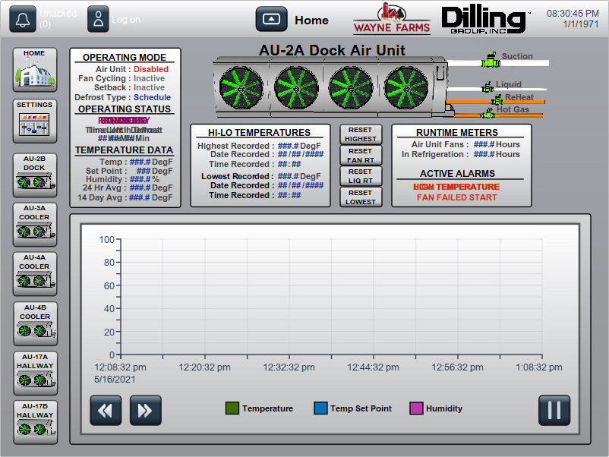
Evaporator Detail Screen

Automatic Control

Each evaporator is controlled from a temperature/humidity sensor located in the air return side of each unit. A temperature set point for each unit is entered at the Graphics Interface Computer. The system controller will add one (1) and subtract one (1) from the set point that is entered to give a two (2) degree dead band. The reheat solenoid operates from a humidity setpoint and will remain on until the humidity has decressed by 2%. If the room humidity becomes greater than setpoint the reheat will come on “energize” until it reaches the offset. There are four (4) solenoid valves for each evaporator, individually controlled depending on the mode of the evaporators as described below. The units fan starters are controlled together with one (1) output from the controller at the Engine Room MCC.

A Satisfied temperature condition is true when the return air temperature for an evaporator is below the two (2) degree dead band. The units will remain Satisfied until the temperature has risen above the two (2) degree dead band.

Controller Action for Satisfied Units:
• Fans On or may cycle if Fan Cycling is enabled Fan Cycling should be disabled for Humidity Control.
• Liquid Valve Closed (de-energized).
• Suction Valve Open (energized).
• Hot Gas Valve Closed (de-energized).
• Re-Heat Valve, controlled by Humidity setpoint.

A Call for Cooling condition is true when the return air temperature is above the two (2) degree dead band. The units will continue to cool until the temperature falls below the two (2) degree dead band. The two-degree dead band is plus and minus one from the setpoint. The Unit fans must be running for the Liquid valve to be energized.

Controller Action for Units Cooling:
• Fans On, will override Fan Cycling.
• Liquid Valve Open (energized).
• Suction Valve Open (energized).
• Hot Gas Valve Closed (de-energized).
• Re-Heat Valve, controlled by Humidity setpoint.

Defrost Control
The Evaporators have Hot Gas to defrost the coils. The following is the defrost sequence and controller action which each of the units will go through when defrost is initiated:

Pump Out Cycle:
Pumpout will remove any existing ammonia from the coil and is typically set from 5 minutes to 30 minutes
• Fans On
• Liquid Valve Closed (de-energized).
• Suction Valve Open (energized).
• Hot Gas Valve Closed (de-energized)
• Re-Heat Valve Closed (de-energized) If unit is calling for Re-Heat.

Hot Gas Cycle:
Removes any frost/ice that has formed on the coil and is typically set from 10 minutes to 30 minutes.
• Fans Off
• Liquid Valve Closed (de-energized).
• Suction Valve Closed (de-energized).
• Hot Gas Valve Open (energized)
• Re-Heat Valve Closed (de-energized) If unit is calling for Re-Heat.

Equalize/Bleed Cycle:
Brings the coil back down from Discharge (hot gas) pressure to suction pressure and is typically set from 3 minutes to 10 minutes.
• Fans Off
• HS Liquid Valve Closed (de-energized).
• HS Suction Valve Closed (de-energized).
• Hot Gas Valve Closed (de-energized)
• Re-Heat Valve Closed (de-energized) If unit is calling for Re-Heat.

Fan Delay Cycle Mode:
Chills the coil back down and freezes any water droplets on the coil before turning the fans back on. Typically set from 3 minutes to 5 minutes.
• Fans Off
• Liquid Valve Open (energized).
• Suction Valve Open (energized).
• Hot Gas Valve Closed (de-energized)
• Re-Heat Valve Closed (de-energized) If unit is calling for Re-Heat.

Settings
All Air unit settings can be changed by selecting the “Settings” Button located on the left side of each air units Detail Screen. The operator must be logged in to access these screen, the settings are broke down into the following three popup screens once “settings” is selected.

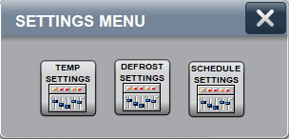
Settings Menu Screen

Temperature Settings
When the “Temp Settings” button is selected the following screen will popup.
Temperature and Misc Settings Screen

Temp/Humidity Setting Values
These set points are used for operation and alarm settings.
The Temp Set Point value can be set from -40 to 140 Degree’s F
The Hi Temp Alarm value can be set from -40 to 140 Degree’s F
The Lo Temp Alarm value can be set from -40 to 140 Degree’s F
The Humidity value can be set from 0 to 100 %
The Humidity Override value can be set from 3 to 7 Degree’s F

Temperature Set Points
The system controller will add one (1) and subtract one (1) from the set point that is entered to give a two (2) degree dead band. When the temperature is above this deaband the controller will put the unit in cooling and will remain in cooling mode until the temperature gets 1 degree below the set point.

Humidity Set Points
The system controller will add one (1) and subtract one (1) from the set point that is entered to give a two (2) % dead band. When the humidity is above this deaband the controller will energize the Re-Heat coil and re-heat will remain on until the humidity gets 1 % below the set point.
Humidity Override can be enabled or disabled with the button shown above. If enabled it will stop the unit Re-Heat from being engergized “On” when the area temperature is “Temp Offset” value above the Temp set point. The Reheat will not be allowed back on until the temperature reaches set point.

Unit Enable/Disable
When an Air Unit is Disabled it will go through a 5-minute Pumpout then all solenoids are De-Energized and fans turned off until its Enabled again. The toggle switches in control panels will override this function

Fan Cycling Settings
If Fan Cycling is not enabled the fans will remain on at all times (except defrost). If Fan Cycling is enabled and the Evaporator is satisfied the fans will run for the amount of time entered into the On time and will cycle off for the amount of time entered into the Off time. Upon a call for cooling the fans will be turned on even if currently off from Fan Cycling. To keep fans off when an air unit is satisfied a zero must be entered in the fan cycle on time.
The Fan On Time Value can be from 0 to 120 Minutes
The Fan Off Time Value can be from 1 to 120 Minutes

Defrost Settings
When the “Defrost Settings” button is selected the following screen will popup. The operator can enter the following values for the defrost cycle under Enter Values in Minutes.
The Pump Out Value can be set from 1 to 20 Minutes
The Hot Gas Value can be set from 1 to 60 Minutes
The Bleed Value can be set from 1 to 20 Minutes
The Fan Delay Value can be set from 1 to 20 Minutes

Demand Defrost
The operator can select whether to use Demand or Scheduled Defrost. By selecting the button below Defrost Type the system will toggle between these two modes. If the Demand Defrost is enabled the controller will accumulate the amount of time which has elapsed in the cooling cycle (Liquid Valve On Time). When this accumulated time reaches the Demand Interval Set Point, the unit will begin the defrost cycle. The Demand Defrost accumulated time will be reset upon finishing the defrost cycle.
The Demand Defrost interval Value can be set from 1 to 168 Hours

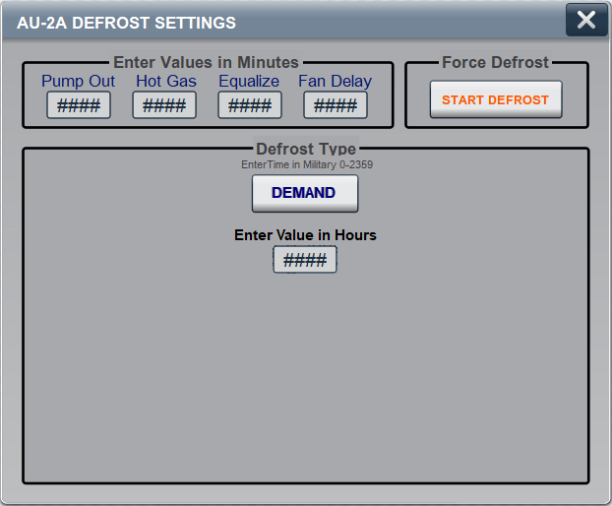
Demand Defrost Settings

Scheduled Defrost
The Scheduled Defrost function allows a seven day defrost schedule to be entered at the operator interface. In this mode an evaporator can be scheduled to defrost up to four (4) times a day. The Defrost Type button is used to choose between a scheduled defrost or a demand type defrost. Schedules for each day of the week must be enabled and time to defrost entered in Military Time. If all defrost schedules are left disabled the unit will not defrost.

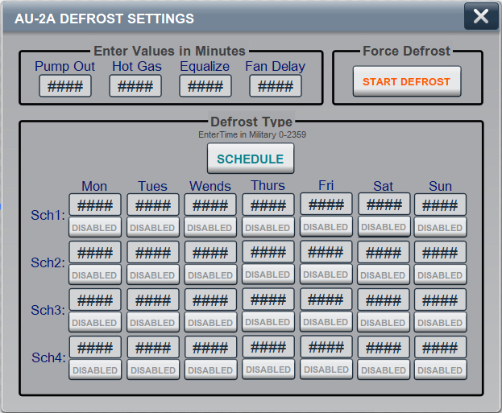
Scheduled Defrost Settings

Force Defrost
The Force Defrost function will allow for an Evaporator to be put into Defrost at any time.
Note: Only one evaporator can go into defrost in at a time so if another is defrosting it wiil wait until other units are finished.

Defrost Groups
The seven air units controlled from this panel are tied together in one defrost group. Only one of these units can be in defrost at a time.

Temperature Setback
When the “Schedule Settings” button is selected the following screen will popup The Temperature Setback function will enable the Evaporators in each area to be set to a different temperature control point at a specific time for a specified duration. There are seven Setback Schedules available to use and must be enabled “below each schedule” in order for that schedule to be active. Below is a description for Schedule 1’s settings.
Temp: Enter the new temperature setpoint desired during the scheduled period.
Day In: Select what day of week you want the schedule to start.
Time In: Enter what time on Day In you want the schedule to start, Military time 0 to 2359
Day Out: Select what day of week you want the schedule to stop.
Time In: Enter what time on Day Out you want the schedule to stop, Military time 0 to 2359
Enable/Disable: button for Schedule 1

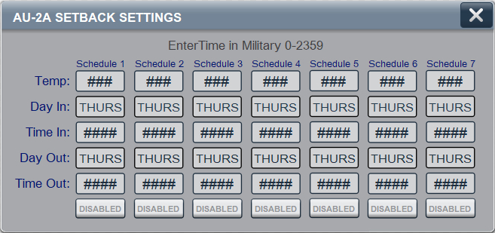
Setback “Schedule Settings”

Time Delay After Power Failure
Upon a power failure the Evaporators will delay sixty (60) seconds between each evaporator before restarting when power has been returned to the panel.

Manual Control
A Selector Switch “Manual Power Feeds” on the control panel door enables/disables power to the manual side of the Switch Banks located in the Air Unit Control Panel. This Switch should only be in the “ON” position if air units are being controlled manually. The Toogle HOA switch banks enable manual control of each air units valves and fans. These switches must be placed in appropriate position for the desired refrigeration cycle (cooling/defrost). This feature should only be used if the PLC fails or some other fault condition causes the operator to need to override all automatic controls. Normal operation all Switches should be in the Auto position.

Manual Cooling
Switch Bank Positions for Unit Cooling:
• Liquid Valve Switch Bank toggle in HAND (energized).
• Suction Valve Switch Bank toggle in HAND (energized).
• Hot Gas Valve Switch Bank toggle in OFF (de-energized).
• Re-Heat Valve Switch Bank toggle in HAND or OFF.
• Fans Switch Bank toggle in HAND (fans running).

Switch Bank Positions for Unit Satisfied:
• Liquid Valve Switch Bank toggle in OFF (de-energized).
• Suction Valve Switch Bank toggle in HAND (energized).
• Hot Gas Valve Switch Bank toggle in OFF (de-energized).
• Re-Heat Valve Switch Bank toggle in HAND or OFF.
• Fans Switch Bank toggle in HAND or OFF.

Manual Defrost
Pump Out Cycle:
Pumpout will remove any existing ammonia from the coil and is typically set from 5 minutes to 30 minutes
• Liquid Valve Switch Bank toggle in OFF (de-energized).
• Suction Valve Switch Bank toggle in HAND (energized).
• Hot Gas Valve Switch Bank toggle in OFF (de-energized).
• Re-Heat Valve Switch Bank toggle in OFF (de-energized).
• Fans Switch Bank toggle in HAND (fans running).

Hot Gas Cycle:
Removes any frost/ice that has formed on the coil and is typically set from 10 minutes to 30 minutes.
• Liquid Valve Switch Bank toggle in OFF (de-energized).
• Suction Valve Switch Bank toggle in OFF (de-energized).
• Hot Gas Valve Switch Bank toggle in HAND (energized).
• Re-Heat Valve Switch Bank toggle in OFF (de-energized).
• Fans Switch Bank toggle in OFF (fans off).

Equalize/Bleed Cycle:
Brings the coil back down from Discharge (hot gas) pressure to suction pressure and is typically set from 3 minutes to 10 minutes.
• Liquid Valve Switch Bank toggle in OFF (de-energized).
• Suction Valve Switch Bank toggle in OFF (de-energized).
• Hot Gas Valve Switch Bank toggle in OFF (de-energized).
• Re-Heat Valve Switch Bank toggle in OFF (de-energized).
• Fans Switch Bank toggle in OFF (fans off).

Fan Delay Cycle Mode:
Chills the coil back down and freezes any water droplets on the coil before turning the fans back on. Typically set from 3 minutes to 5 minutes.
• Liquid Valve Switch Bank toggle in ON (energized).
• Suction Valve Switch Bank toggle in ON (energized).
• Hot Gas Valve Switch Bank toggle in OFF (de-energized).
• Re-Heat Valve Switch Bank toggle in OFF (de-energized).
• Fans Switch Bank toggle in OFF (fans off).

Alarms\Warning
Operator adjustable High Temperature Alarm set point.
Operator adjustable Low Temperature Alarm set point.
Fan Fail Start Alarm, fan told to start and no auxiliary conformation back from the starter.
Temperature Sensor Failed Over/Under Range Alarm.
Humidity Sensor Failed Over/Under Range Alarm.
Unit Disabled Warning.

Parts List Air Unit Control Panel
See prints for Item No. locations

